



Implementation of iterative statements - while loop
LAB MANUAL

Disclaimer: The content is curated from online/offline resources and used for educational purpose only
Implementation of iterative statements - while loop
Objectives:
To implement a Python program that demonstrates the use of iterative statements, specifically a while loop. The program should perform a repetitive task until a specified condition is met, allowing users to observe the behavior of the loop and its effects on program execution.
- To demonstrate the use of a while loop in Python by printing a sequence of numbers from 1 to 5. The program should increment a counter variable in each iteration until the specified condition is no longer met.
- To implement a Python program that utilizes a while loop to repeatedly prompt the user to guess a number until they provide the correct answer. The program should demonstrate how loops can be used to control program flow based on user input.
- To implement a Python program that utilizes a while loop with a break statement. The program should decrement a variable until a specified condition is met (in this case, when the variable equals 5), at which point the loop will terminate early.
- To implement a Python program that demonstrates the use of a while loop with a continue statement. The program should increment a number from 0 to 10 and print only the odd numbers, skipping the even numbers during each iteration.
Problem Statement:
- Write a Python program that initializes a counter variable to 1 and uses a while loop to print the value of the counter until it reaches 5. The program should increment the counter by 1 in each iteration. Once the counter exceeds 5, the loop should terminate.
- Write a Python program that allows the user to guess a predetermined number (in this case, 7). The program should keep asking the user to input a guess until they correctly identify the number. Once the user guesses correctly, the program should congratulate them and terminate.
- Write a Python program that starts with a number (10 in this example) and decrements the number in a loop until it reaches 5. The program should print the current value of the number in each iteration. When the number reaches 5, the loop should terminate using a break statement, and the program should print a message indicating that the loop was terminated early.
- Write a Python program that initializes a number to 0 and uses a while loop to iterate until the number is less than 10. In each iteration, the program should check if the number is even. If it is, the loop should use the continue statement to skip the printing step and proceed to the next iteration. The program should print the odd numbers only.
- Write a Python program that starts an infinite loop asking the user to enter their name. The loop should print a greeting message for each entered name. If the user types "exit" (case-insensitive), the program should break out of the loop and print a message indicating that the loop has exited.
Equipment Required:
- Install VS Code - https://code.visualstudio.com/download
- Download Python Installer File - https://www.python.org/downloads/
Prerequisites:
- Basic Computer Skills - Anyone starting to learn computer programming needs basic computer skills. Python is a cross-platform language, so it makes no difference whether you use a macOS, Windows, or even Linux.

Procedure:
Task 1: Loop while counter is less than or equal to 5
Task 2: Correct number to guess
Task 3: Decrement the number until it reaches 5, then break the loop
Task 4: Skip the rest of the loop for even numbers
Task 5: Infinite while Loop (with break)

Task 1: Loop while counter is less than or equal to 5
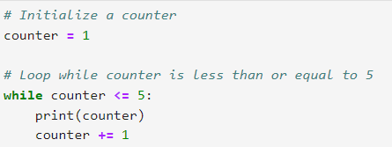
Output:

This output shows the numbers from 1 to 5 printed sequentially. After the fifth iteration, counter becomes 6, causing the loop to exi
Task 2: Correct number to guess
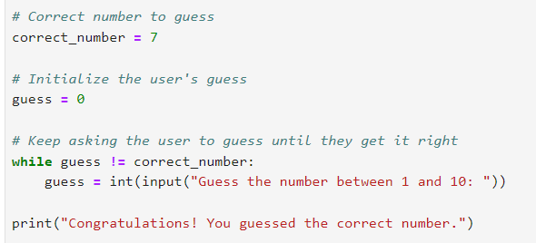
Output:
This output shows how the loop allows the user to keep guessing until they find the correct number, effectively demonstrating the functionality of a while loop with a condition based on user input.
Task 3: Decrement the number until it reaches 5, then break the loop
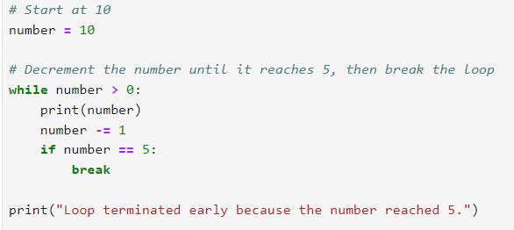
#Output:THIS O/
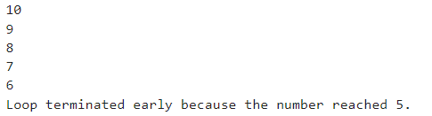
This output shows how the loop decrements the number from 10 down to 5, printing each value along the way and demonstrating the use of a break statement to terminate the loop early when a specific condition is met.

Task 4: Skip the rest of the loop for even numbers
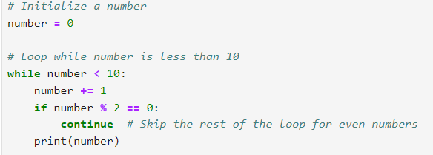
Output:
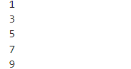
This output shows the odd numbers from 1 to 9 printed sequentially. The even numbers (2, 4, 6, 8, 10) are skipped due to the continue statement, demonstrating how it alters the flow of the loop by bypassing specific iterations.
Task 5: Infinite while Loop (with break)
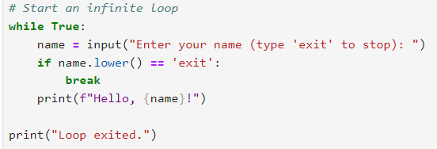
Output:
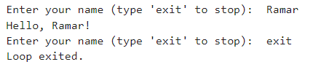
This output demonstrates how the program allows for multiple greetings until the user chooses to stop the interaction by typing "exit." The use of an infinite loop in conjunction with the break statement effectively manages user input until a specified condition is met.

